Tic-Tac-Toe Game
AIM:
To write a Python program to implement the Tic-Tac-Toe game for two players.

ALGORITHMS:
- Start.
- Initialize a 3 × 3 board with empty cells.
- Set player X as the first player.
- Display the board.
- Ask the current player to enter a position.
- Check whether the selected position is valid and empty.
- If invalid, ask the player to enter another position.
- Place the player's symbol in the selected position.
- Check whether the player has completed a winning combination (row, column, or diagonal).
- If a player wins, display the winner and stop.
- If the board is full and there is no winner, declare a draw and stop.
- Otherwise, switch to the other player and repeat from step 4.
CODE:
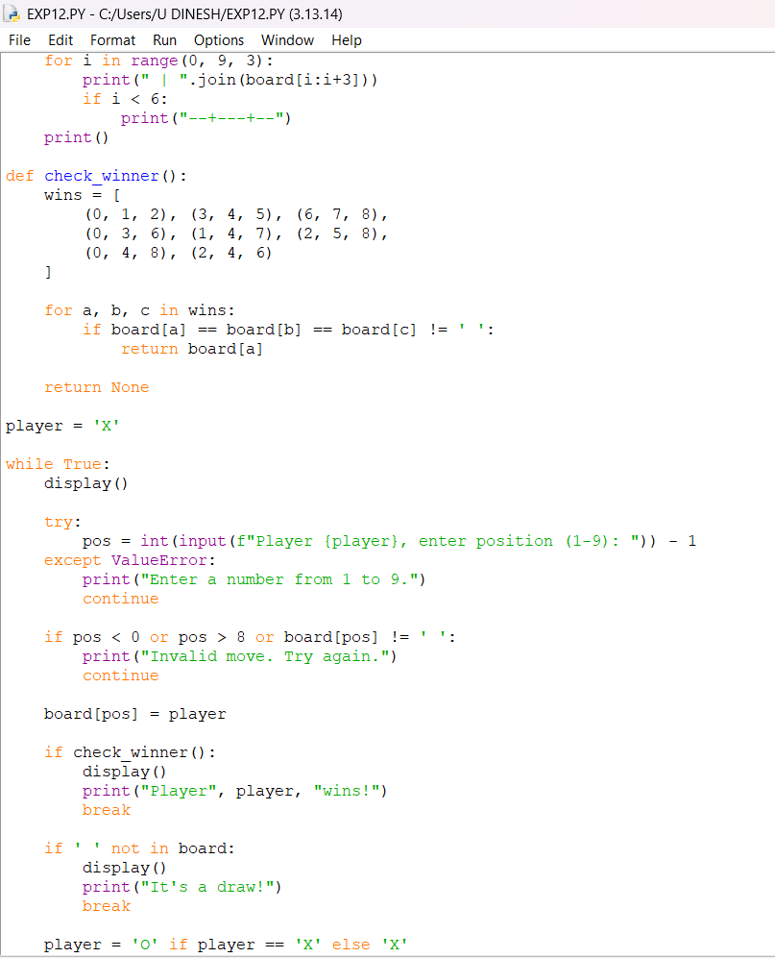

OUTPUT:
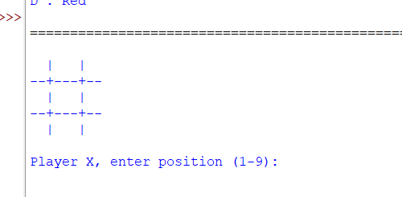

RESULT:
Tic-Tac-Toe Game: The game is implemented successfully, allowing players to play and determine the winner or a draw.

